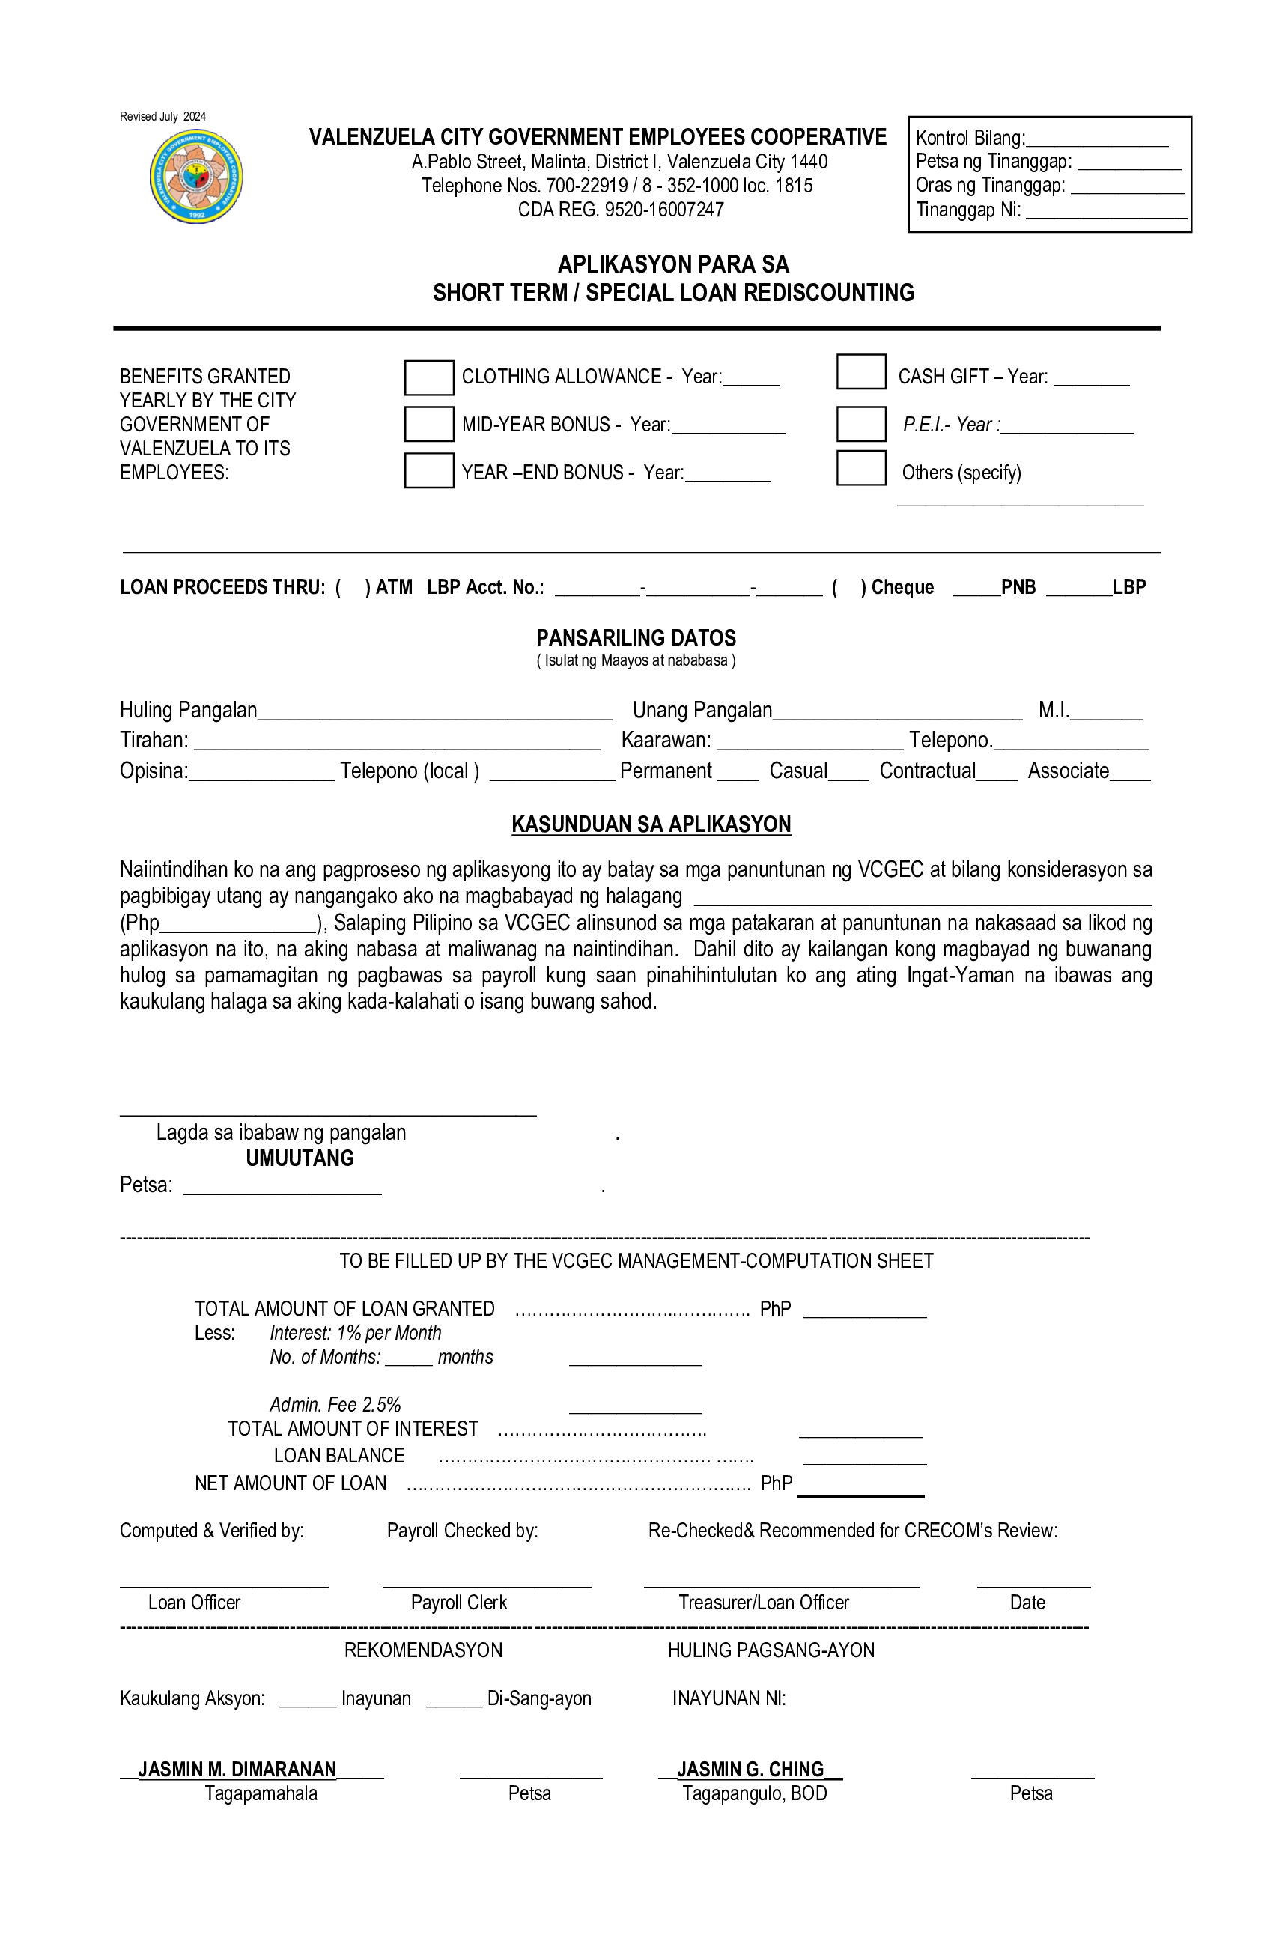

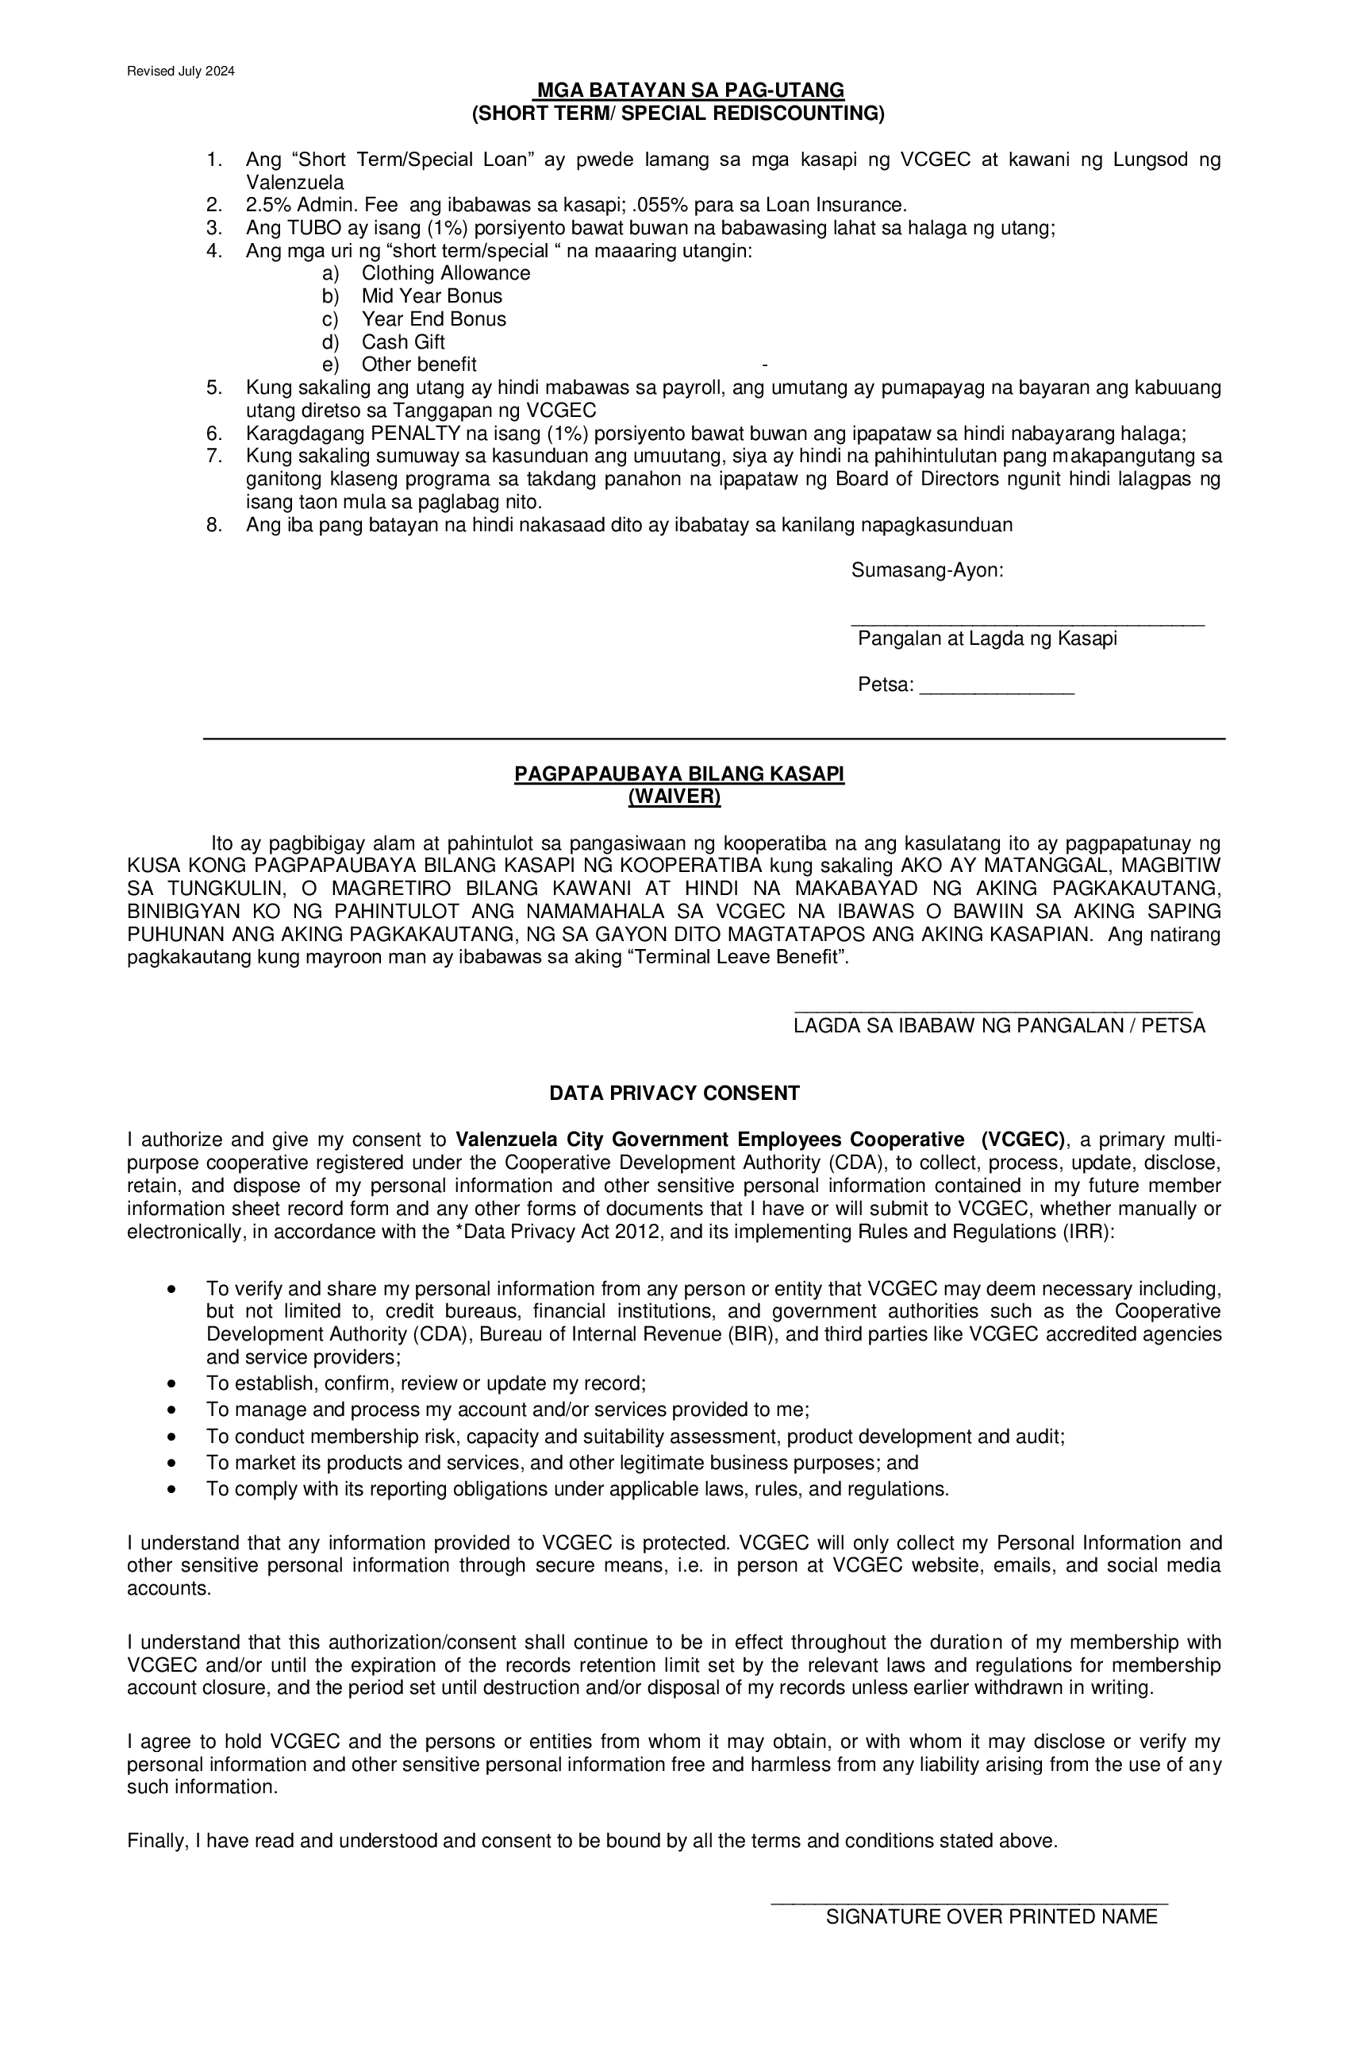

__________________

DATE

MS. JASMIN G. CHING

Chairman, Board of Director

Valenzuela City Government Employee Cooperative (VCGEC)

Dear Sir:

Good day!

May I request from your good office to allow the undersigned to avail the rediscounting of my R

__________________________________________________.

Net proceeds will be used for (State reason of request):

Your kind consideration and approval of my request is very much appreciated.

More power to VCGEC and God bless us all

Very truly yours,

_______________________________________   
SIGNATURE OVER PRINTED NAME OF MEMBER

APPROVED BY:

MS. JASMIN G. CHING

BOD Chairman VCGEC

lra